The Monticello Tulip Poplar II Tables
Capturing the full life of Thomas Jefferson’s
“Juno of the Woods”
By Frederick Williamson

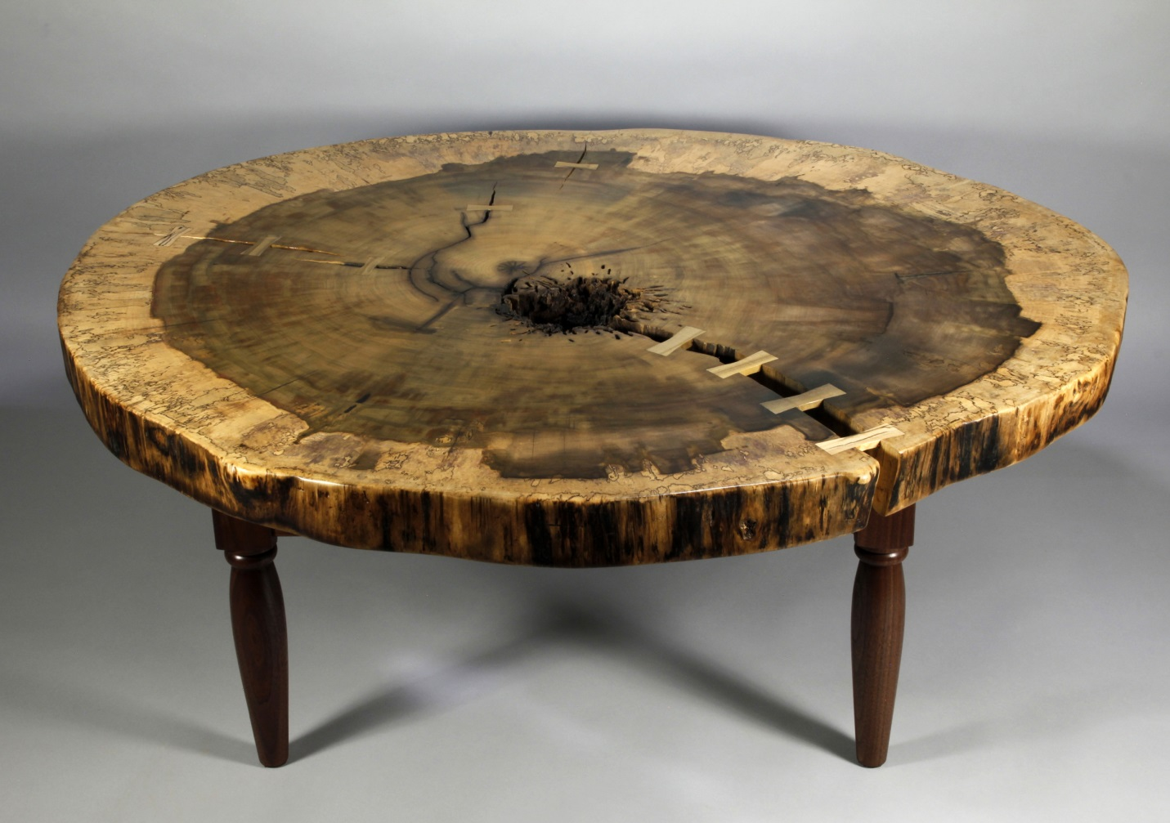
The lawn side of Monticello was graced by the presence of two magnificent Tulip Poplars which towered over Thomas Jefferson’s house. For decades they were tended, pruned, wired for lightning protection, and cabled to safeguard the house. I had been fascinated by them from the first time I saw them around 1982, gazing up in awe at the spreading crowns so huge and stately, stuck by the dramatic trunks. So in the summer of 2008 I was shaken to learn that the largest of the trees was dying and had to be taken down. And then in 2011 the second tulip poplar had to come down.

I had done various turnings for Monticello since 1997, both architectural pieces and some bowls from the Silverbell and the Copper Beach that were taken down on the lawn. But the giant Tulip Poplars were in a league of their own. Peter Hatch agreed I could work with the wood if arrangements could be with Sharon McElroy on how to document and sell the bowls. Since then I have turned some 750 bowls and made thirty coffee tables and benches from this spectacular wood, and various other local artisans have greatly expanded the range and number of items made from the trees at Monticello.

I wanted to capture and preserve some significance of those enormous trees, and to that end I decided to make two tables from the Tulip Poplar II. They are from cross sections solid down to the heart, are the result of seven years of planning and work, and are utterly unique.

An Overview of the Process
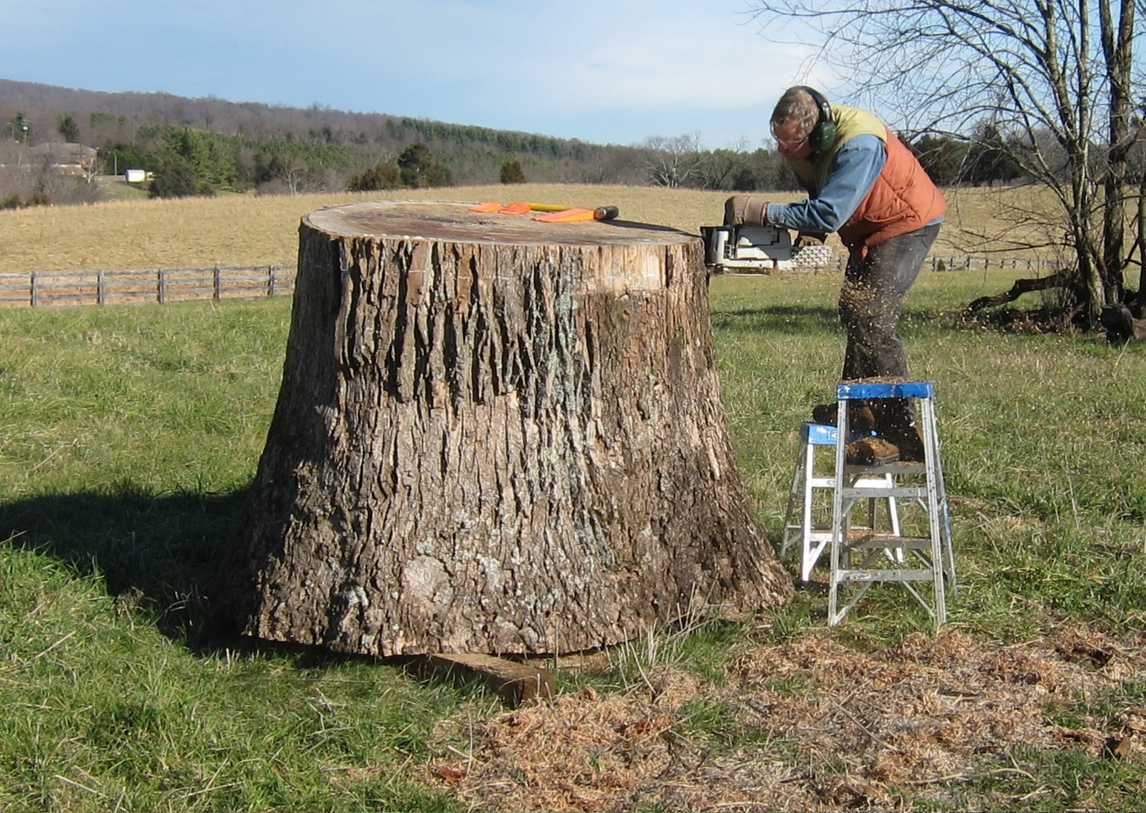It all began December 30, 2011.

The logs of the second tulip poplar had been moved to the Peter Jefferson field in Shadwell, where I had sealed the ends and erected shade coverings over the largest ones. Of particular interest was the butt log, which proved to be sound at the pith at the top.
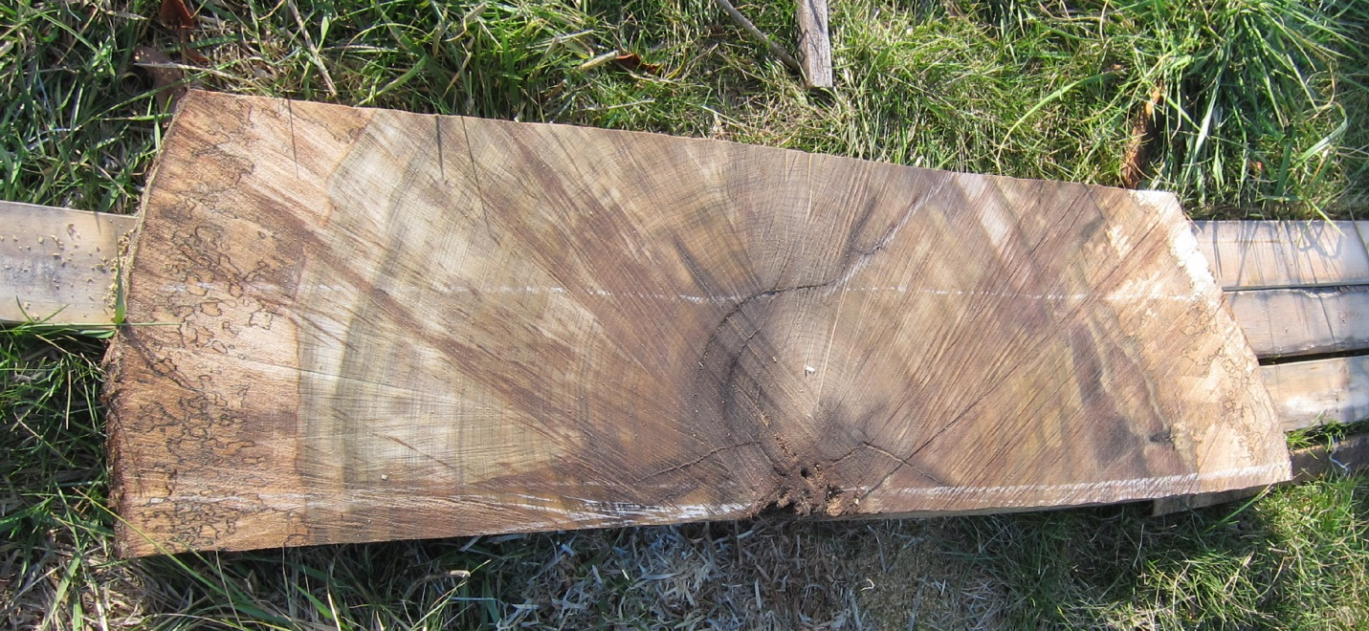The Dating Slice
Here is the slice that Bob Self sent to Dr. Daniel Drukenbrod of Rider University, who had an ongoing project dating many of trees at Monticello. The larger Tulip Poplar on southwest corner that was taken down in 2008 was hollow, and therefore could not be dated. But this cross section from the second Tulip Poplar went right to the heart, and therefore Dr. Drukenbrod was able to definitively date it to 1808.

While I was working up the log I decided that this was such a momentous tree it deserved to be remembered in a special way, so I cut a full cross section cut just above the dating slice.

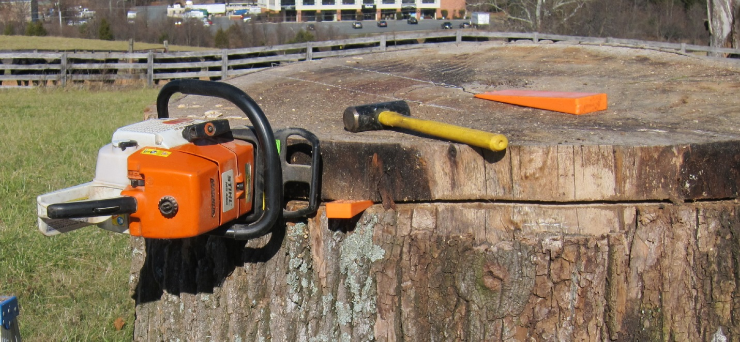
Working my way around with a 32” bar chain saw.

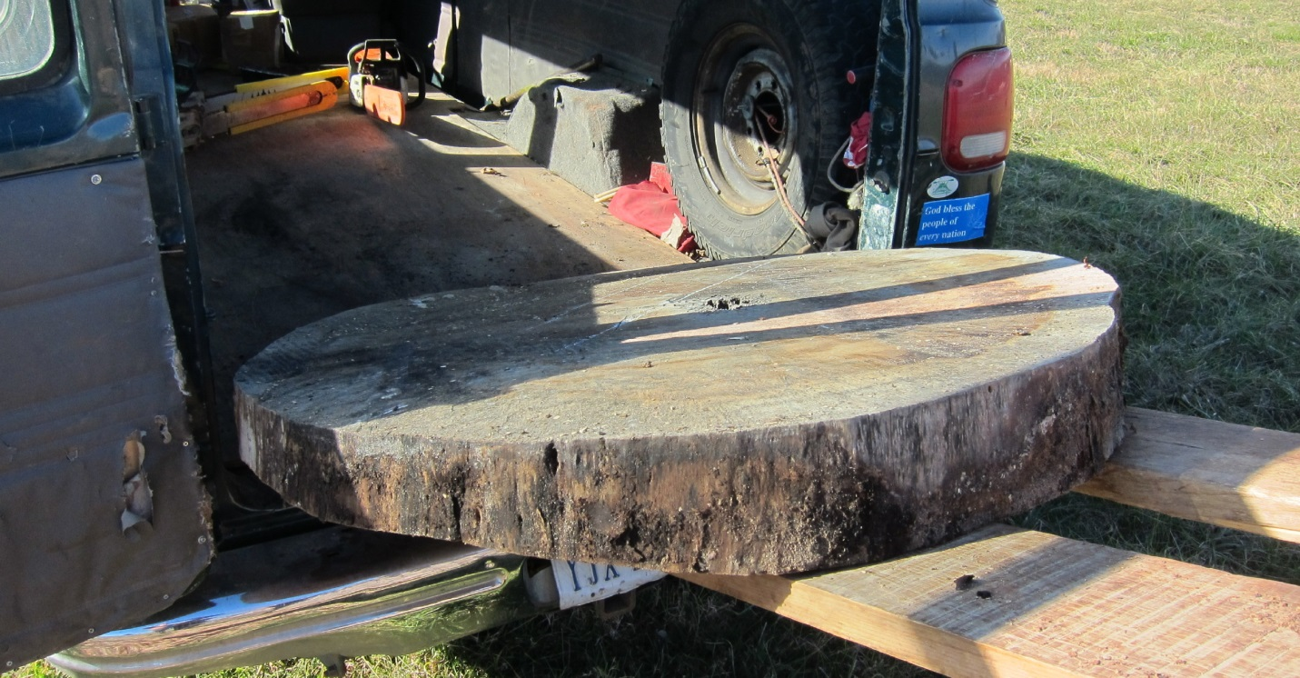
This will become Table #30.
This piece was immensely heavy, and was barely able to fit into the back of my van.
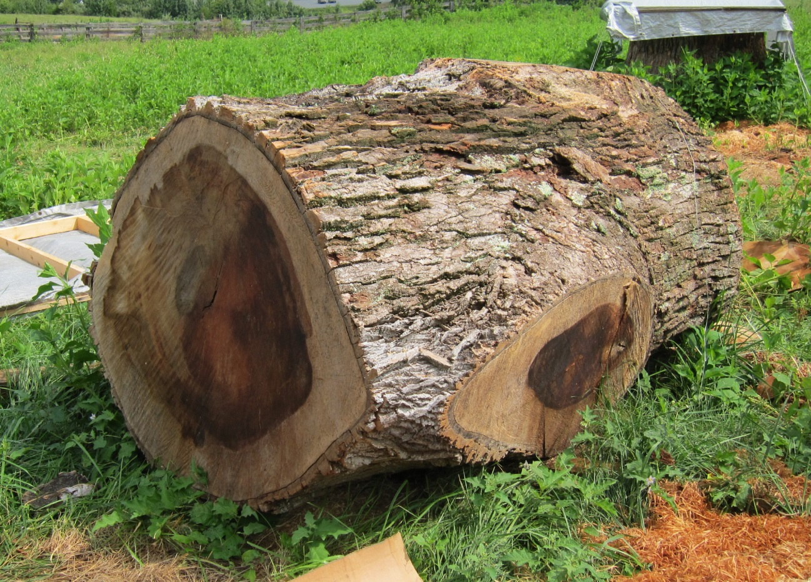
The trunk section for the used for Table #29.

At the same time I cut a cross section from the log that was about 25 feet up the tree, where the Tulip Poplar had branched into two main branches. When I got it home I sealed them on both sides with Anchorseal and stored them behind my shop out of the sun and rain, where they stayed for six months for the initial drying. But I was worried that decay might get into the sections as they were close to the ground, so in June of 2012 I brought them into my studio to further dry.

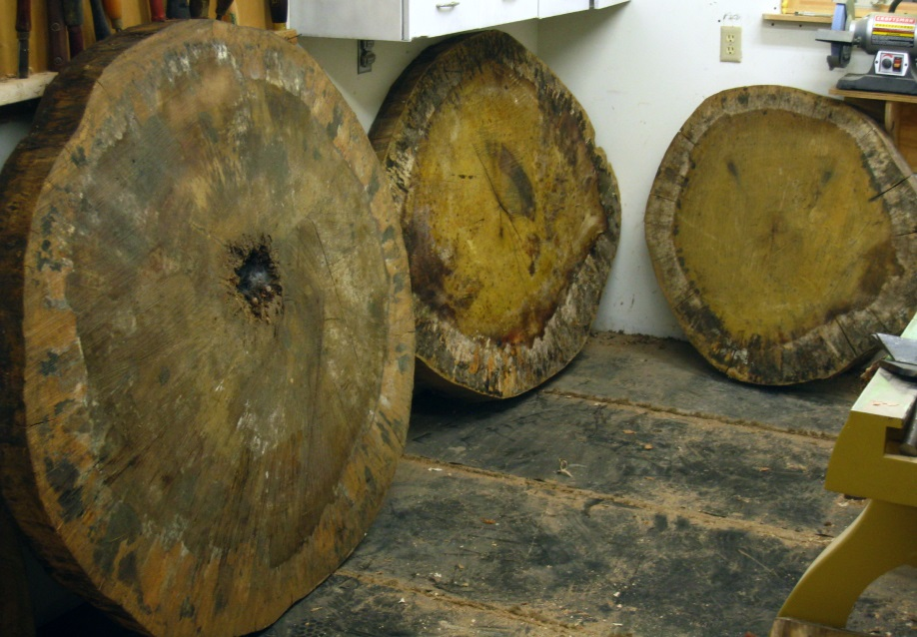
Here are the sections when I first brought them into the studio.
They remained in a side room for about three years, where I carefully monitored them. Despite all my sealing and controlled environment efforts, all three of these sections developed multiple cracks, which then morphed into one major crack in each section. This is somewhat inevitable on full cross cuts of trees.

In September of 2013 I moved along in the process, setting up a router sled to machine the surfaces flat and parallel.
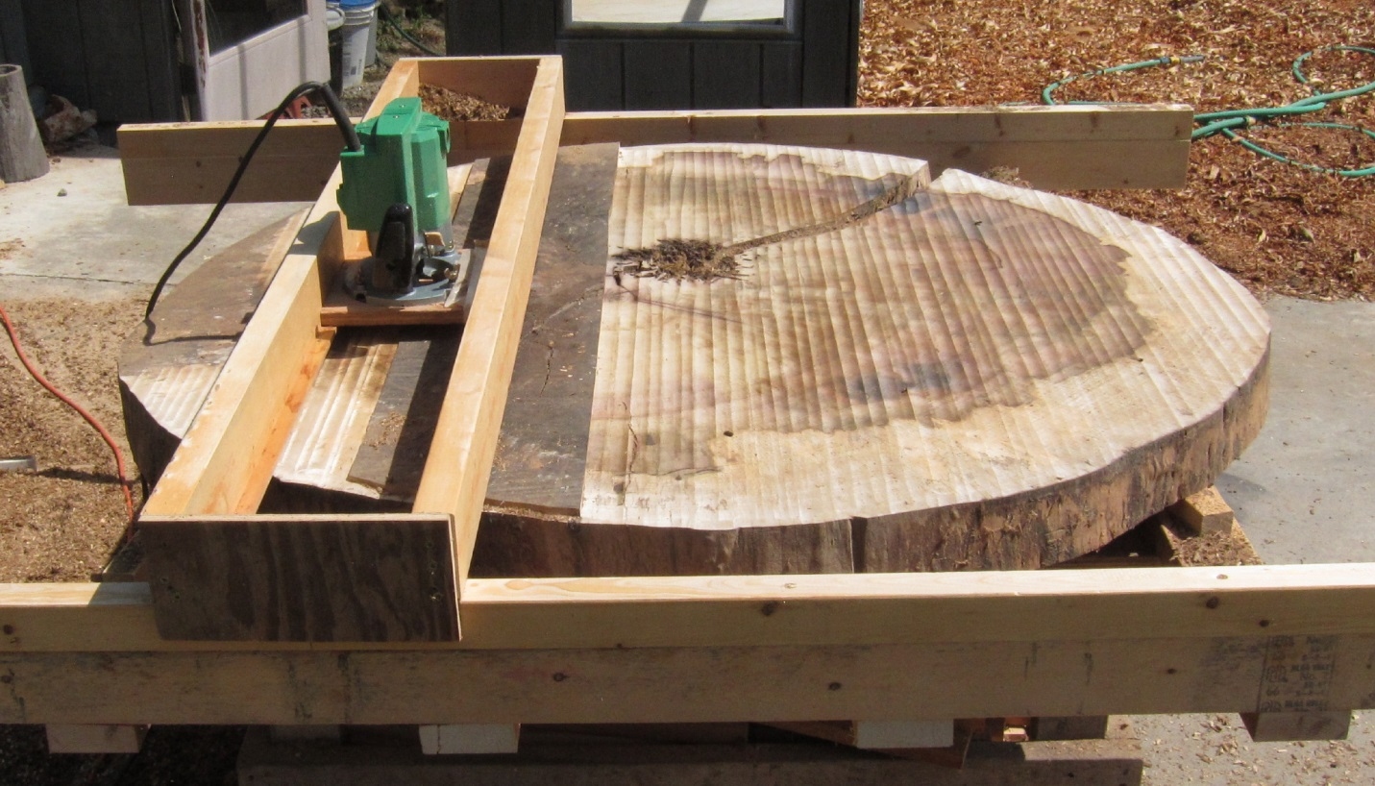
Here is #30 in process
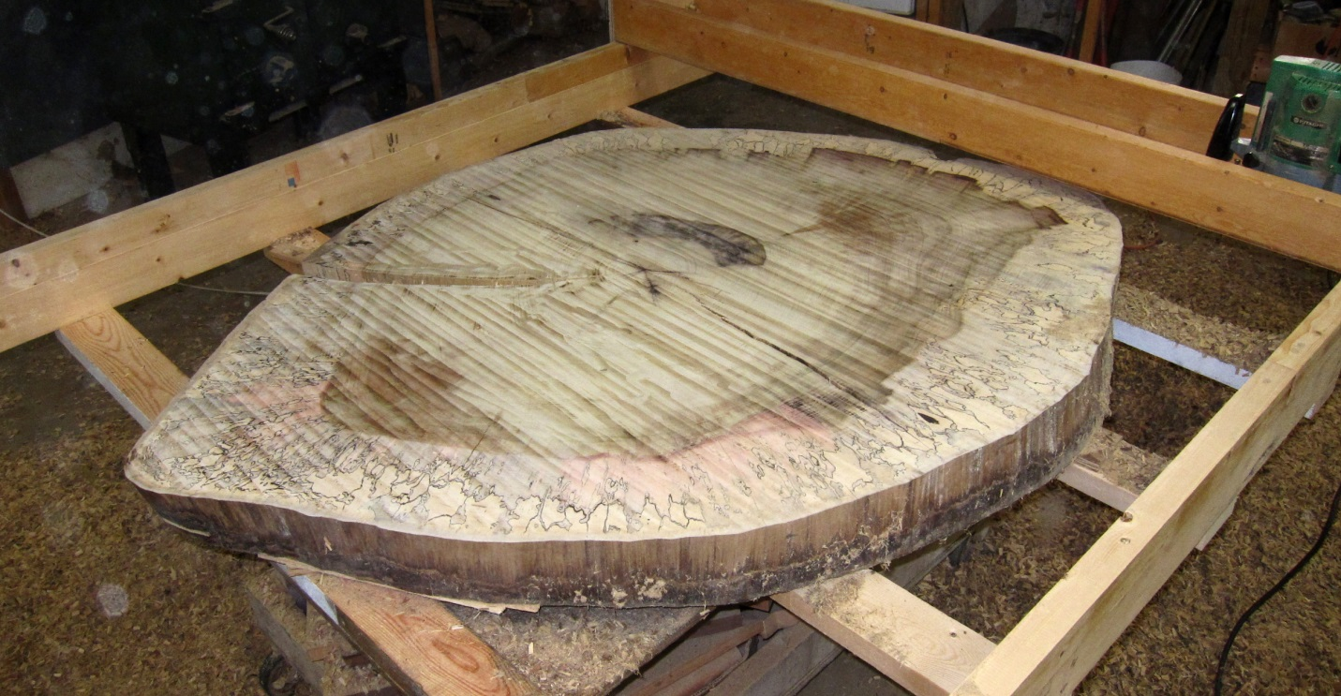
and here is #29.
Now flattened, the two sections were moved into the basement of my house and clamped between stiffening 2x2s, where they slowly dried further until they were stable and at equilibrium with the dry conditions I maintain in our house.

In the spring of 2018 I brought them back out to the studio, where I let them acclimate for several months before proceeding with the final process.

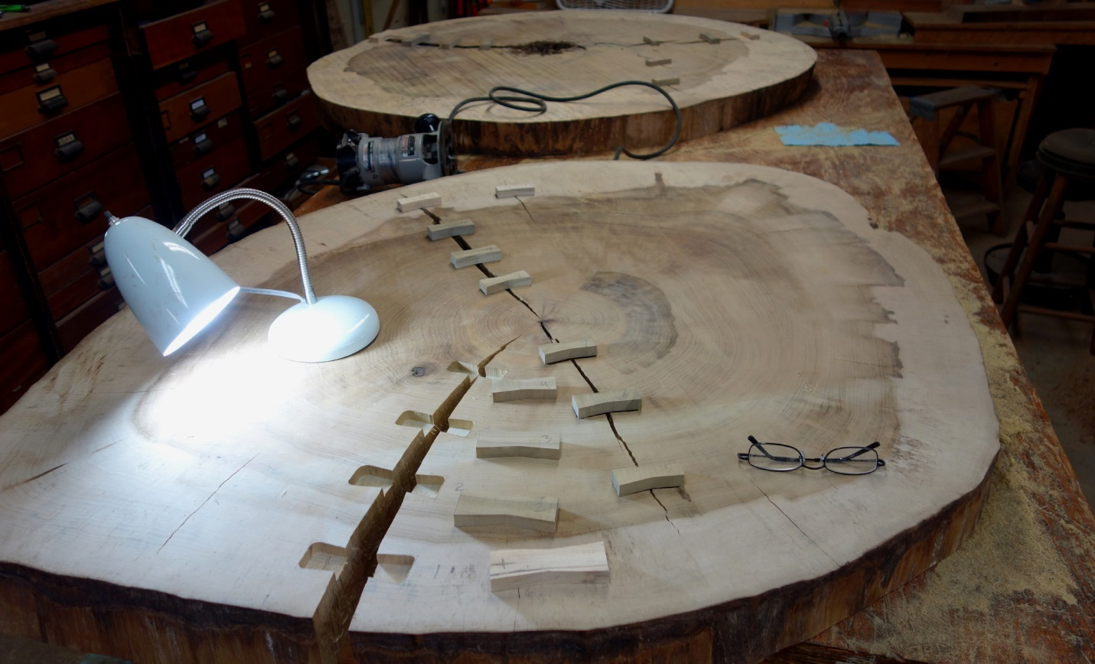The butterfly joints
The first step was to cut and install butterfly joints to firmly secure each piece so it could never fall apart. For the butterflies I used Monticello Tulip Poplar wood cut and seasoned for years to an utterly stable condition. Each was color selected to match the cross sections as closely as possible, and the butterflies were gradated in size according to their position. After the butterfly was traced on its intended position I hand-routed the slots and then carefully pared the sides down to match each butterfly. There are 20 butterfly joints in the big table, 26 in the smaller one, firmly securing them.
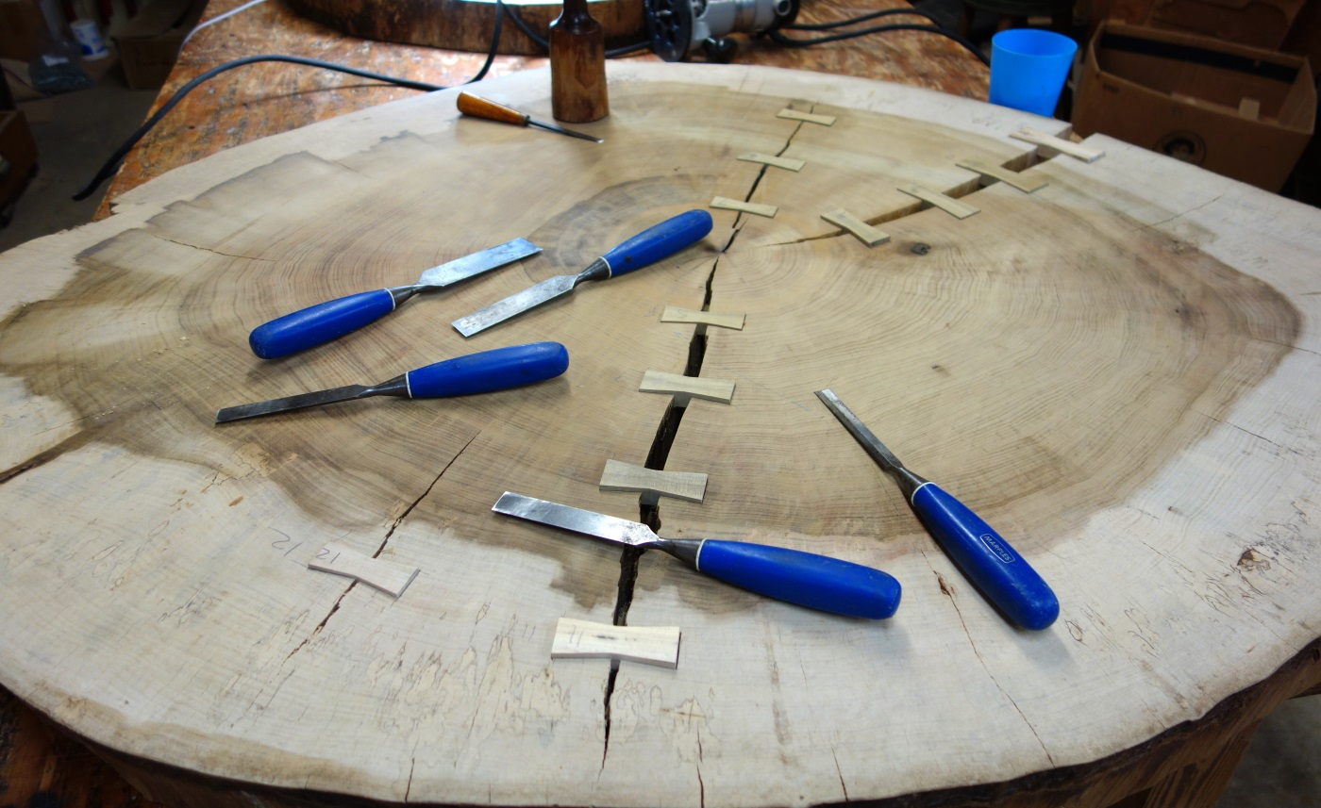
Ready to glue up.
I made bases out of black walnut, using 3” thick stock to turn the legs with a simple classical ogee curve I felt would fit the Jefferson style. The bases are designed to give firm support while providing simple, inconspicuous contrast to the dramatic tops.
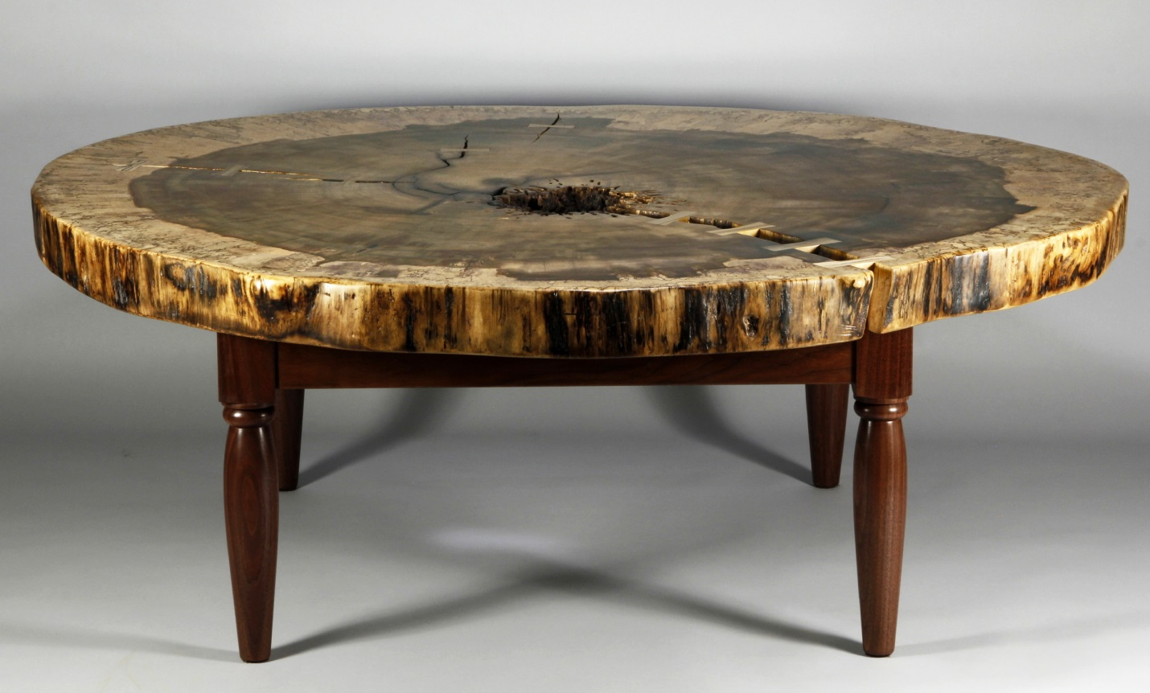 Here is the Table #30. This is from the butt cut of the log, about 5’ off the ground, representing the whole life of the tree from Thomas Jefferson’s era until it was cut in 2011. It is 55 ½” by 48” in diameter and stands 20 ¼” tall.
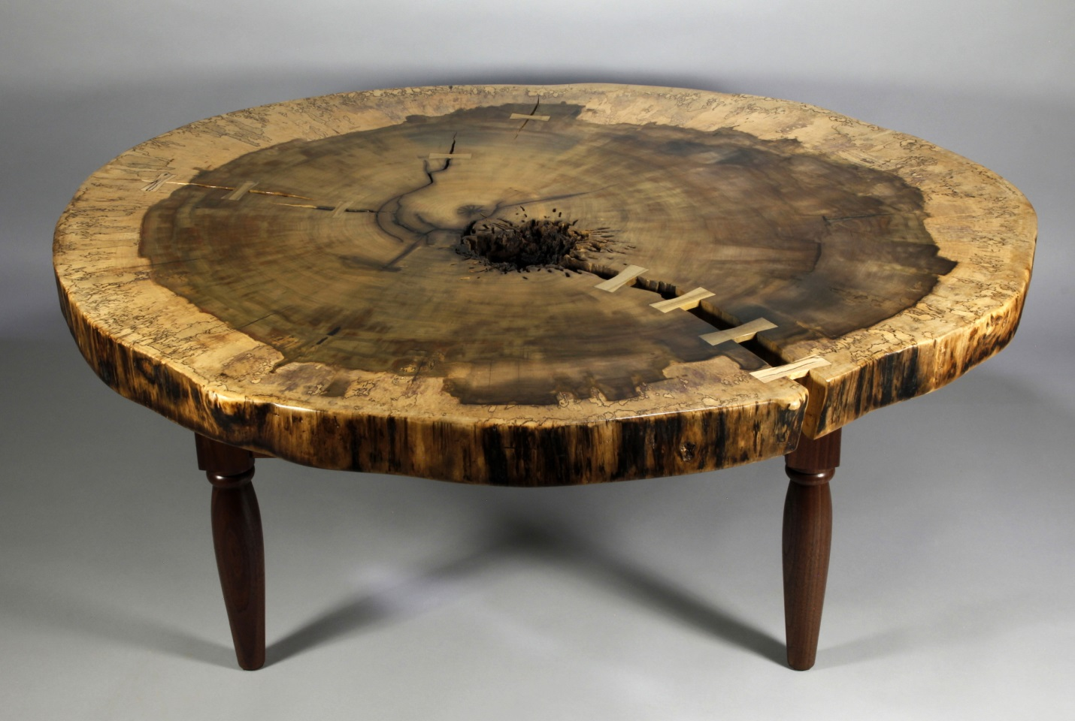
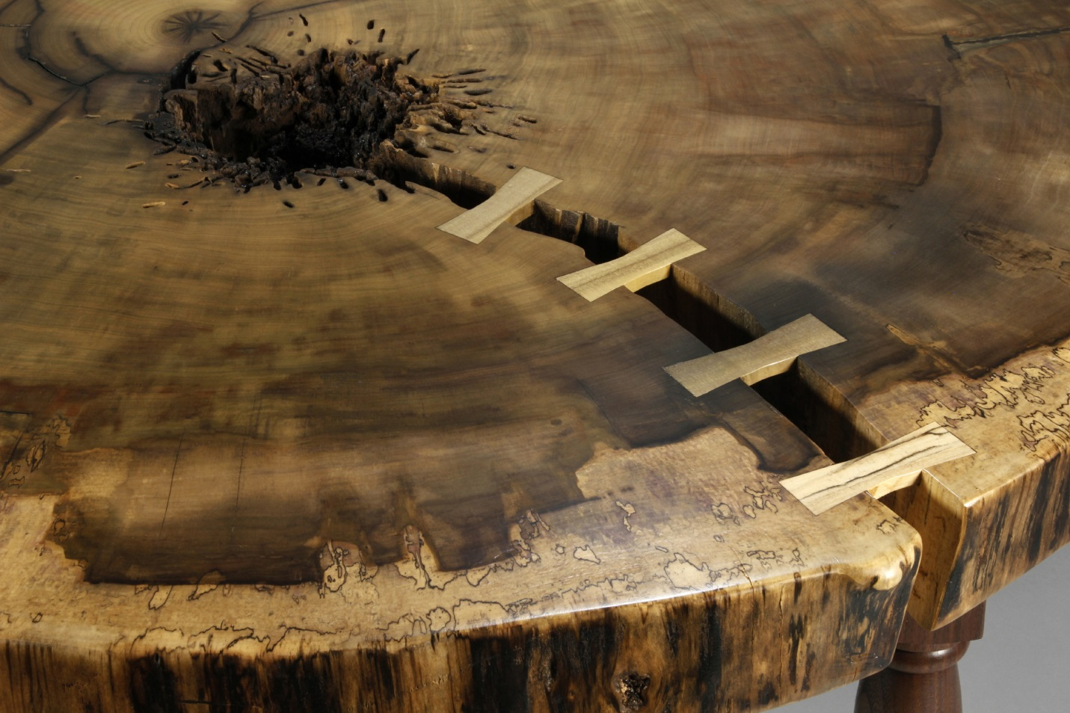Here is a close up of some of the butterfly joints on #30,
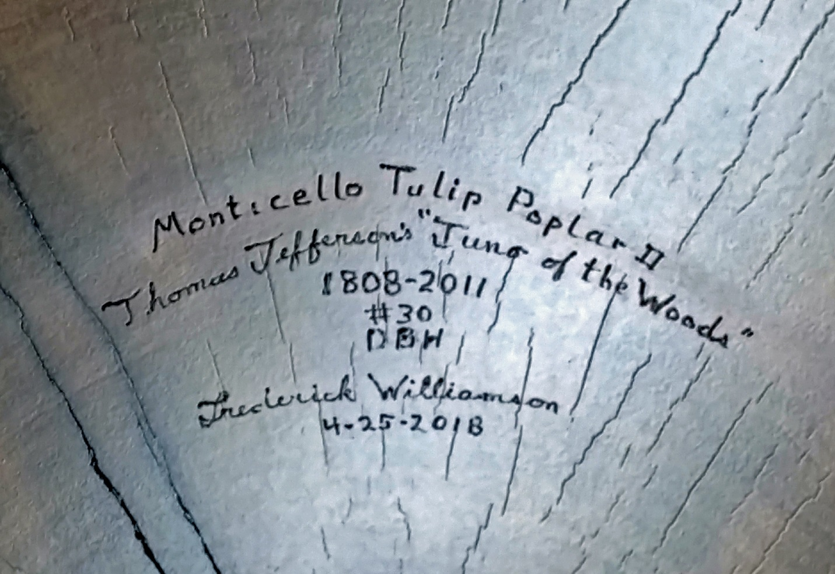and the signature on #30 underneath.

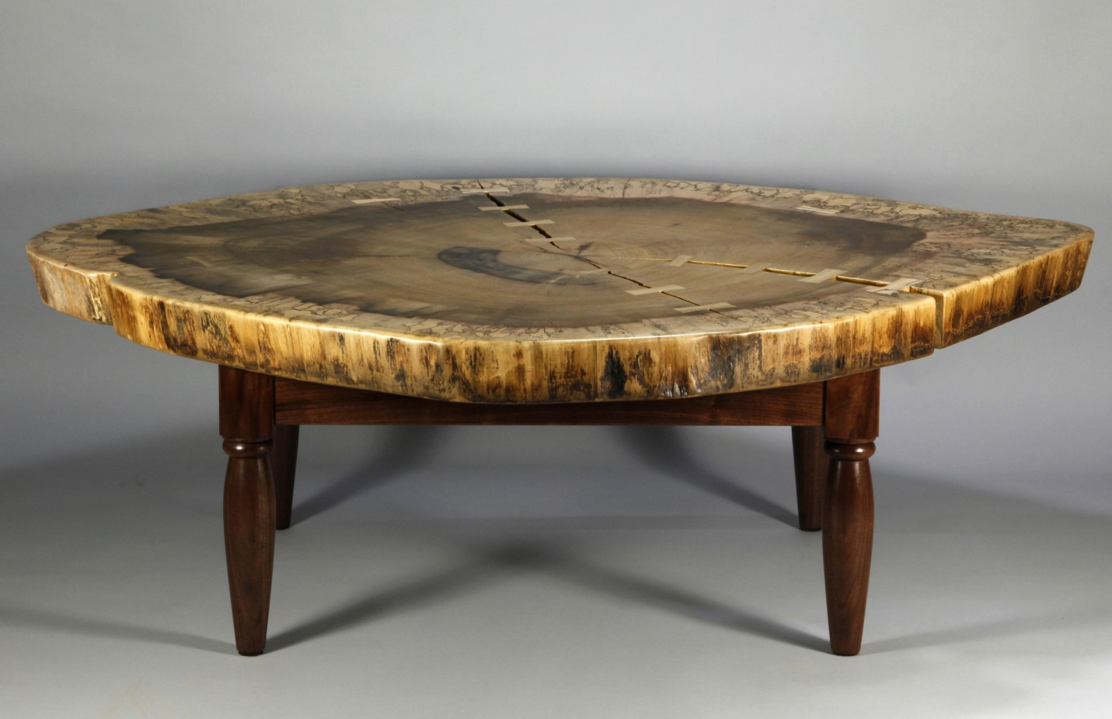
Table #29
Here is the Table #29, from the tree just below the first crotch perhaps 25’ off the ground. It is 56 ½” by 41” in diameter by 20 ¼” tall. It also comes with a shorter base to make it 18 ¾” tall, for a more typical coffee table height. But the tables are so big they look better at 20 1/4” tall.

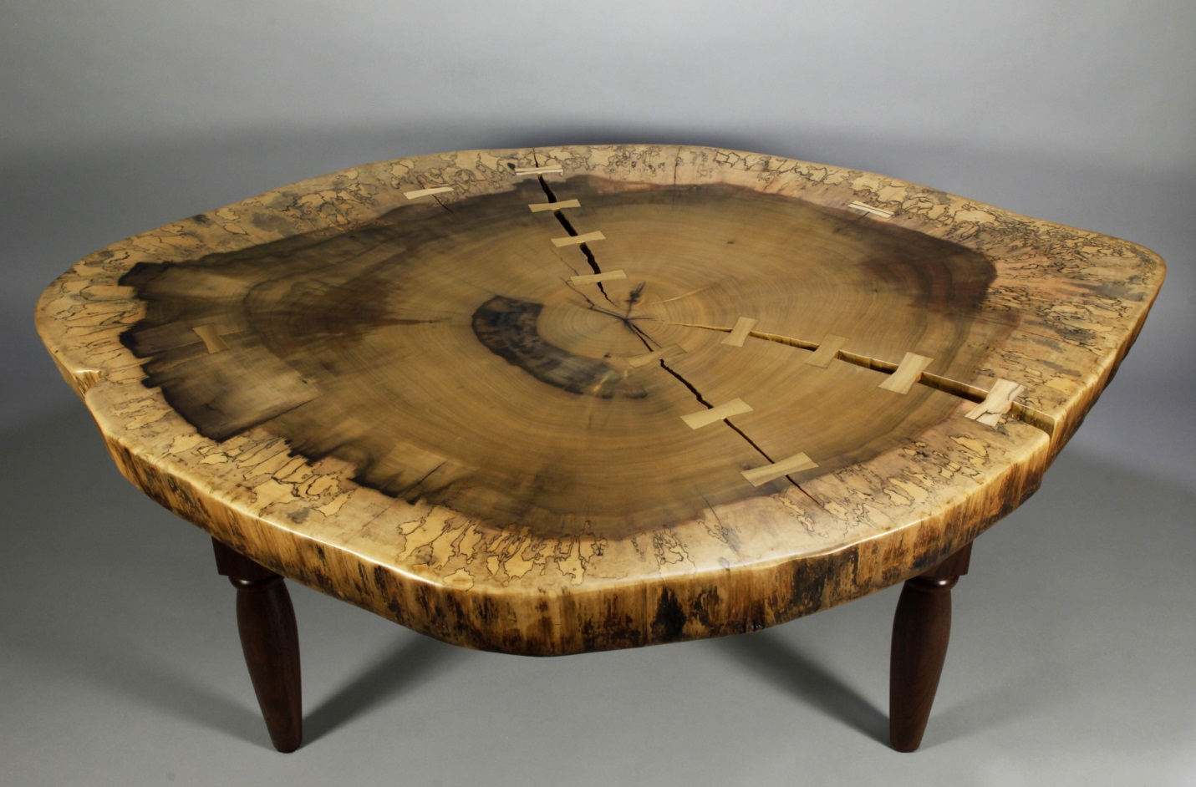Here is #29 from above,
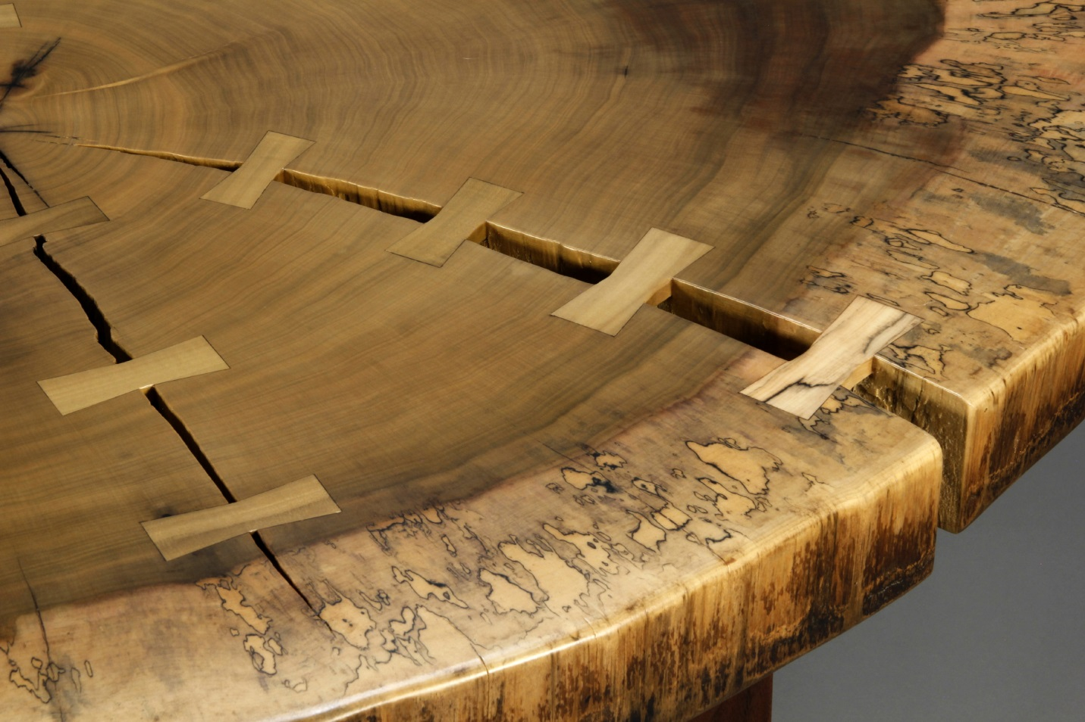
a close up of some of the butterfly joints on #29,
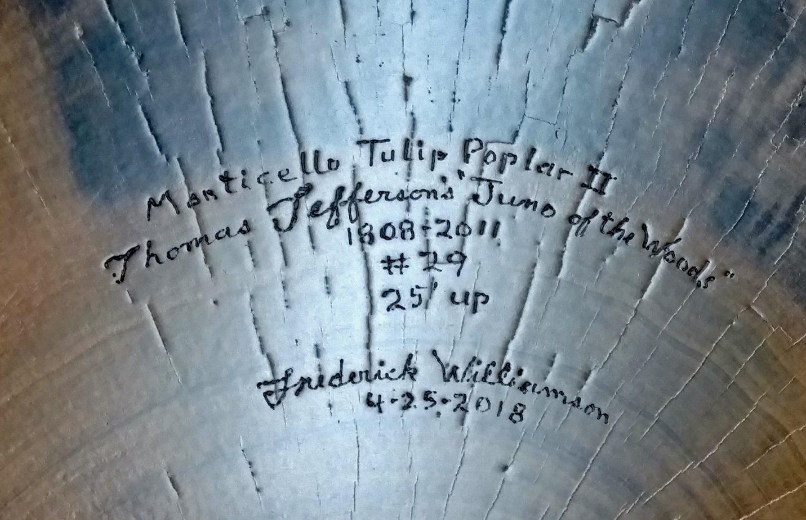
and the signature underneath.

