My Philosophy on Working with Monticello Wood
Frederick Williamson
June 30, 2016

It has been a great honor for me to be able to work with this wood from the trees at Monticello. I am always mindful of Thomas Jefferson and his legacy when I turn bowls from the marvelous tulip poplars that stood beside his home, which that I so admired while they were alive.

Jefferson was a complex man, standing astride both the old world and the new. He celebrated the new world, was caught up in documenting everything there, and wholeheartedly threw himself into creating a new government and a new order. He embraced change. Yet at the same time he embraced his European roots, reveling in his mastery of all the classics: Latin, Greek, Italian architecture, the violin.

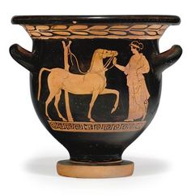
Thomas Jefferson had a profound classical bent combined with a desire to be innovative and unburdened by the past. His creations in architecture and household innovations reflect that dichotomy. A vivid example is his design of the “Jefferson Cup,” at once elegant, simple, and minimalist. Yet it references the classic design of the krater, used by ancient Greeks to mix wine and water. Take off the foot and flared lip or neck, remove any handles, and you have the basic shape of the Jefferson cup.

This runs in the back of my mind when I am turning bowls from the woods at Monticello. My desire is for each turned piece to have its own presence. The simple shape of the Jefferson cup lends itself to this. I wish to feature the wood itself most of all, and choosing a simple, pleasing shape that is secondary to the overall effect does this.
So the first bowl turned from each block of the Tulip Poplar is typically this shape. This also allows me to maximize the number of bowls I can get, for I can use a coring tool to cut out the center of the bowl, which can then be remounted to turn a second bowl, and perhaps a third bowl can be cored out of that. These bowls are necessarily shallow in shape.
Here is a typical progression:
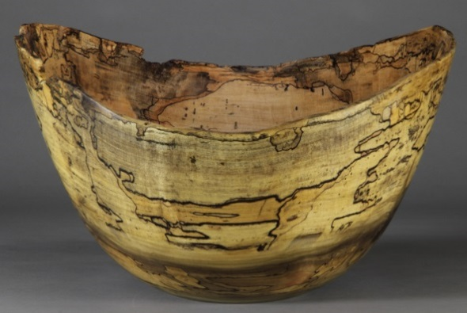 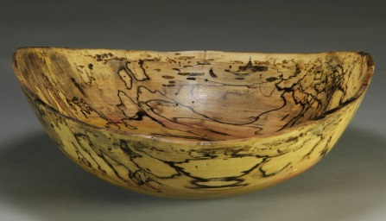 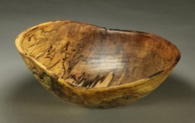
But there is no reason to make every bowl the same shape. I respond to each piece of wood, working out what will best feature the wood and have the most presence. Here is where the New World comes in, as I believe Jefferson would probably have embraced these contemporary shapes in their turn.

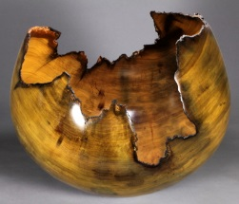 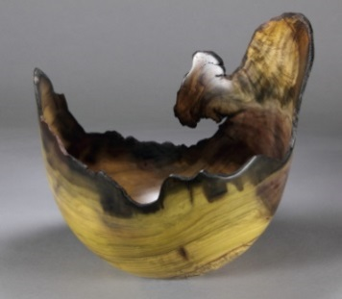 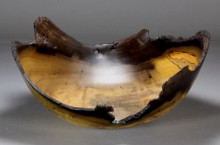 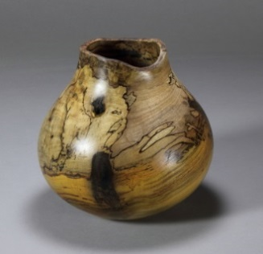
When the upper edge is wildly dramatic from the effects of the hollow tree, or the block lends itself to a globe or a shallow open piece, I will turn that. Polished smooth, dried to a stabilized state, and given a hand-rubbed clear finish, the thin arcs of wood display the character and history of the tree, bringing out the inherent beauty of figure and grain.

When people hold one of these pieces in their hands I want them to feel a connection with the historical past which this wood represents. These trees were planted during Jefferson’s time, and although not nearly as old as some trees can get, they were old and quite dense for tulip poplars. They show the mark of time. This is accentuated by the vivid spalting, the dark stains from nails or rot, and the wonderful fire-hardened effect of the surface that was inside the hollow tree for decade after decade.

This is my basic philosophy that has guided me as I have worked with the wood from the trees around Monticello. The two stately giants that framed the house from the lawn side are of course the most special, but the other trees have had a similar effect on me, from the silver bell and the copper beech that I first turned, to the hackberry, mulberry, and sugar maple from Mulberry Row, not to mention the huge sugar maple that blew down in 2011 by the privy. There is simply something magical about the hilltop soil of Monticello that has grown trees that are particularly rich and dense.

But I’ve gotten into more than just bowls with the Monticello wood. When the second tulip poplar came down and I saw all the logs at Shadwell it was clear to me I and my fellow turners could not deal with the quantity of wood before it deteriorated too much. But knowing dried lumber can last forever, I talked with Bob Self about getting some of it sawn into boards while he was having the big timber sawn for the salt trough. He chose the two clearest logs and August 8, 2011 they were sawn up into mostly 5/4” boards, wonderfully wide. I then got permission to come back January 2, 2012 and again June 6, 2013, when Jim Hart (the band saw mill sawyer) sawed up the last big log left in the field. With coffee tables in mind, I chain sawed complete rounds from some of the ends, and slabs off the branch stubs. This lumber was carefully stacked to air dry at my shop for a year, and then I took it to be kiln dried. Something about the field at Shadwell caused the poplar to spalt most wonderfully, and the resulting lumber often has highly figured sapwood.
But while I had the band saw mill out I had some 2” and 3” thick slabs cut in addition to my chain sawn slabs.
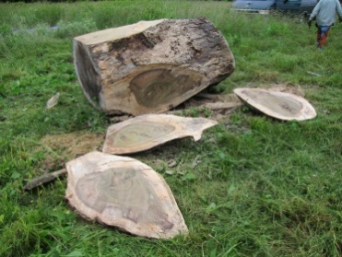 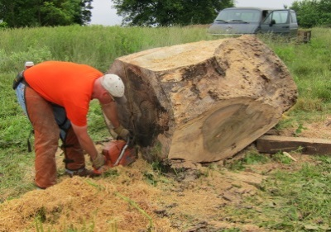 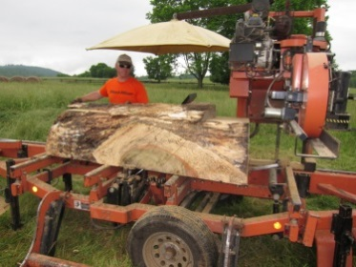 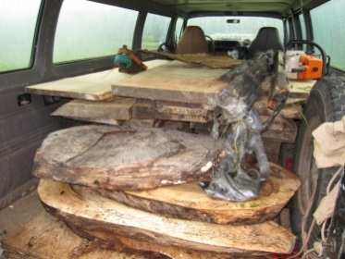
Slabs chain sawed off Jim Hart quartering the log the band saw mill at work headed home to be air dried

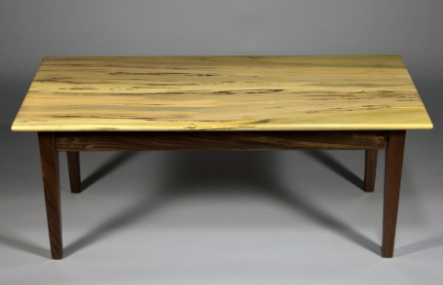
I am making three types of furniture from this. The first is coffee tables made using the 5/4” boards. These tables are the simple classic design with square tapered legs. After trying bases out of poplar I determined that walnut worked much better to feature the poplar tops. It became clear that the more figured the poplar is, the more people responded to it, and I have selected and set aside some of the most figured stock for more tables like this. Some of it is quite dramatic. I have four full size tops and a few side table tops all finished and awaiting the skirts and legs that need to be made.
It took a long time for the chain sawn slabs to dry sufficiently. I am just now making the first set of benches and coffee tables with them. These are entirely unique, and have presented some difficulty working out the best style. Once again, walnut seemed to be the best choice for the bases. But the thicker tops have a more rustic feel. I have decided to focus on that, and the connection to the rural nature of Monticello. Jefferson created a sort of villa plantation in the midst of the wilderness as it were, while so many colonial settlers were living quite rustic lives. But even Monticello was rustic at heart. Hand tools were the thing of the day. The salt trough was hand hewn as were building timbers, and one of Jefferson’s main sources of income was selling hand cut nails made there at Monticello.

A fellow artisan named Jim Lakiotes from West Virginia makes stools and benches this time honored way, with hand hewn legs created by using sledge hammer and wedge, drawknives, and spoke shaves, and working on a shaving horse. I commissioned him to make a set of walnut legs for me, and here is the result:
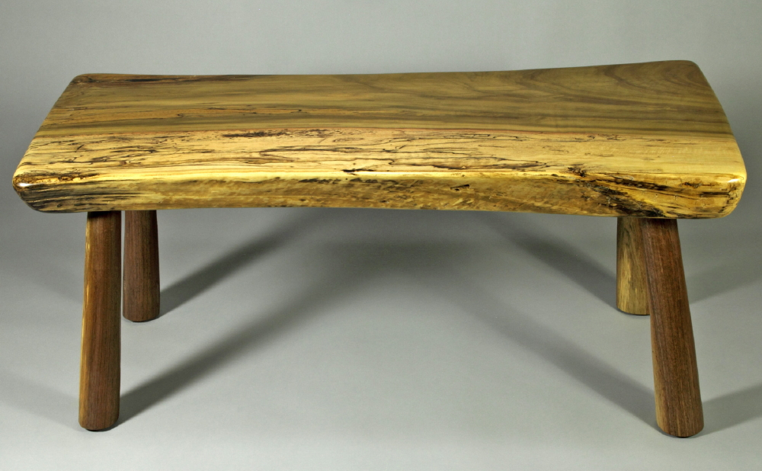
The 1 ½” tenons on these legs are epoxied into the top, and the ends and heartwood sides of the top are beveled and curved to match the natural edge facing you in this photo. I have several smaller slabs like this finished, and planks for maybe 12 more stored in my basement waiting to be worked up. The beauty of dried lumber is it will store forever if kept dry and away from powder post beetles and such.

Then there are the free form slabs. Here is my first effort at a coffee table with them.
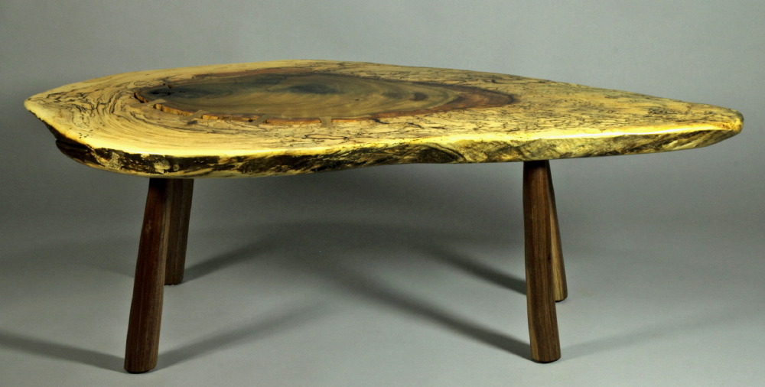
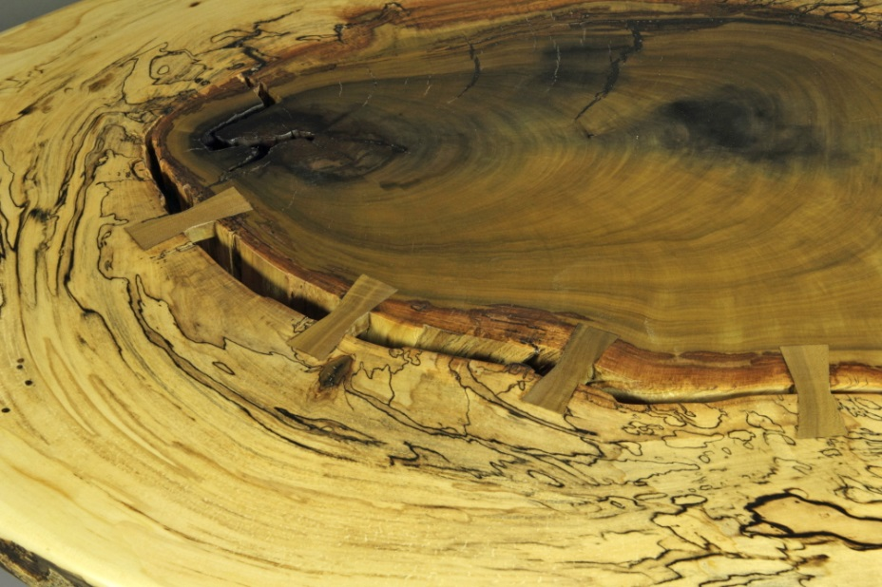 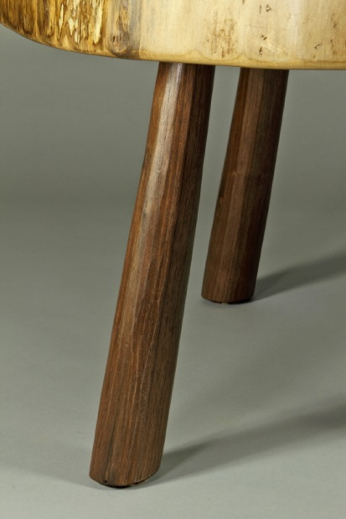
These butterfly keys are cut from the carefully saved darkest Monticello tulip poplar I could find from the board stock. There is a mirroring set of butterfly keys underneath, so although is it profoundly cracked, the top is quite stable. And this is a close up of the hand worked walnut legs. I find this table wonderfully unique, and it really shows the special nature of the huge tulip poplar.

I have one more slightly smaller top like this all finished and waiting for some more legs to be completed, and something like 6, maybe 7 more other oval slab blanks, some of them thinner, and that will be it.

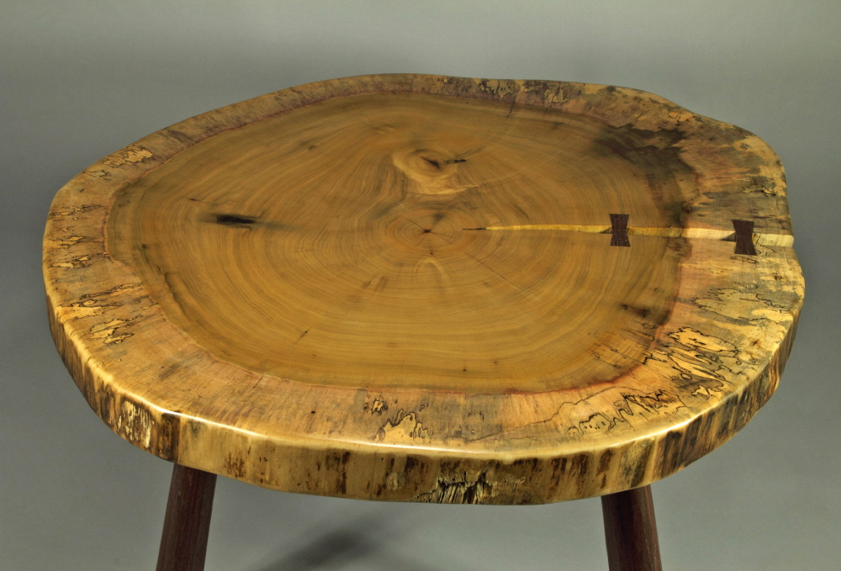
And finally, here is the finished cross section top. I believe this section of the tree came from right above the last main lateral branches in the tree. It was perhaps 40 feet up in the tree, and would be some years younger than the base of the tree, but no more than 25 years younger. Nearly 200 years old.

I have two more full cross sections still curing in my house. One is from maybe 20 feet up and is represented by this photo. It was cut just past this end, and by the flared tips you can see it was right before the two main huge branches took off. The second one is from right below where I cut the cross section used by Mr. Drukenbrod to date the tree, and is quite dramatic, as it shows the entire life of the tree being cut at “DBH”, or “diameter breast height” which is used in measuring and dating trees. They are both about 55” at their widest diameter, and have been machined flat by router jig and are going through final drying now.
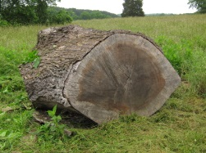
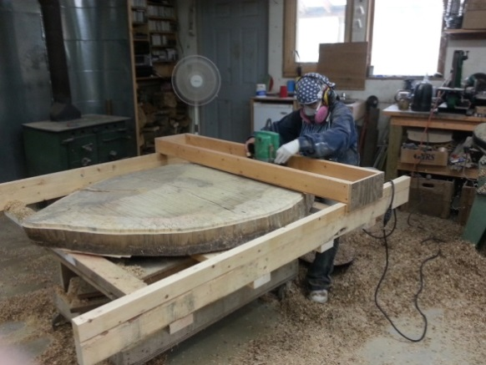
Frederick Williamson
5623 Sugar Ridge Road
Crozet, VA 22932
434-823-1882 fredwilliamsonwood@gmail.com www.fredwilliamson.com

